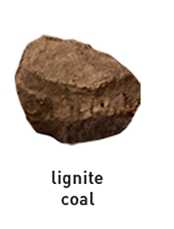
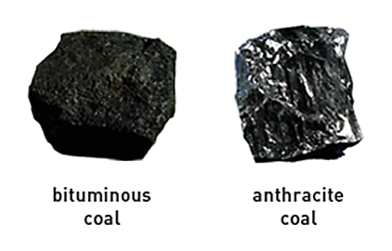
Coal Facts
Bingo
Brown/  Crumbly | Shiny/  Metallic | Hard Coal | Soft Coal
Burns Cleaner | Formed in Mountains of Pennsylvania | Formed right after Peat | Low Heat Content
Spongey | Free Space | Purer Form | Most Common Type of Coal
Used in Soil Today | Has three layers | Used to heat homes | Lowest Rank of Coal

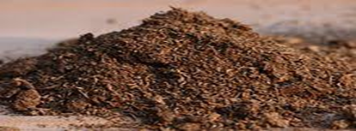

Teacher/Activity Facilitator Notes

Depending on the age of group, complete one of the following:

Read “How Coal was Formed” (as they follow along on their study buddy)
- Send home accompanying study buddy for home study over the week (or a time allotment of your choosing). Then, play bingo with students.

Present “Fueling America: A Coal/Coal Mining Overview”
- Send home accompanying study buddy, and/or have students take notes on presentation. Then, play bingo with students.

Playing Coal Facts Bingo (regular card)

Simply write out the following words on scraps of paper:

Bituminous Anthracite Lignite Peat

Then, fold the papers, put them in a basket, and randomly select one at a time. The students will have to know the characteristics/facts of each type of coal in order to know where to place their bingo markers.

Playing Coal Facts Bingo (picture card)

Alternatively, use picture bingo card and tailor facts/characteristics from the regular card to your group’s capabilities. In this case, facts/characteristics should be written on scrap papers.

*Bingo is saved as a Word document so that you can create more bingo cards. You will have to shuffle up the facts on each card.

Coal Facts
Bingo

 |  |  | 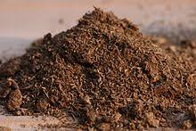
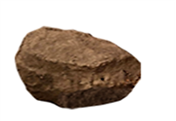 | 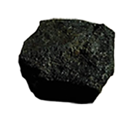 | 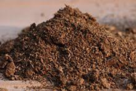
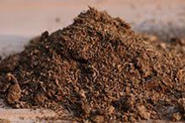 | Free Space |  | 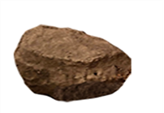
 | 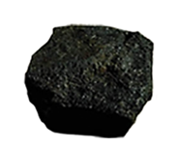

How Coal is Formed

Three-hundred million years ago, the earth was covered with huge swampy forests of giant ferns, reeds, and mosses. Some of these plants died and fell into the swamp waters and new ones grew in their place. This happened in a cycle until there was a thick layer of dead plants rotting in the swamp. A change in the earth’s surface washed in dirt and water stopping the plants from rotting even further.

The cycle did not stop. Plants kept growing, dying, and falling until a separate layer formed. Millions of years helped create many layers one on top of the other. Heat and pressure changed the plant layers pushing oxygen out and leaving carbon behind. These decayed, or rotted, plants, leaves, and bark became Peat.

Peat, the youngest of them all, is the first stage before the rotted plants, leaves, and bark became coal. Peat is brown, crumbly, and spongey. It is used today for soil in places like golf courses and lawns. Peat formed first, and then turned into different kinds of coal like lignite, bituminous and anthracite.

Lignite is the lowest rank of coal and has the lowest heat content. With added heat and pressure, bituminous coal was formed.

Bituminous coal, also known as soft coal, is the most common type of coal. Bituminous coal looks smooth at first glance, but actually has 3 layers – vitrain, clarain, and fusain. Vitrain is glass-like wood. Clarain is dull and grayish and is formed out of plant debris. Fusain is charcoal-like and is chemically changed wood.

Anthracite coal, the final stage of coal, is known as hard coal, is black and metallic-looking. Anthracite coal is used for heating homes. It is also found almost entirely in Pennsylvania.

Mr. Coal’s Family
Study Buddy
The Coal family comes in all shapes, sizes, and colors. Study the family tree below.
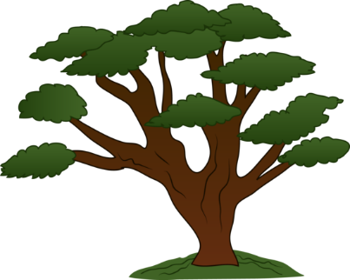
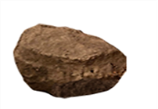
I am soft and the most common type of coal in my family. I have 3 layers.
Bituminous
Lignite
Anthracite
I am hard coal. I am metallic, burn cleaner, purer form, and formed because of pressure in mountains of Pennsylvania.
I am the lowest rank of coal and have the lowest heat content.
Peat
I am Peat and first in the family. I am brown, crumbly, sometimes spongey, and originally used in Europe. Today, I am used in soil in places like golf courses and lawns.

heat content.
plant leaves bark

