Coal Mining Activity

Materials Needed:

Dirt – 1 and 1/4 cups

Flour – 1 and 1/4 cups

Sand – 1/2 cup

Salt – 3/4 cup

Water – slowly add it until you reach a clay-like consistency

Toy tools or other gadgets to dig out the coal

Lump of coal (can be purchased at Eckley Miner’s Village, or a dark rock may substitute as coal)

Activity Prep:

1. Mix the dirt, flour, sand and salt in a large bowl or bucket.

2. Add the water until you reach a clay-like consistency.

3. Put the mud all around the coal until it looks like big chunks of rock.

4. Leave the “rocks” out to dry or bake at 175 for 1.5 hours

Activity Instructions:
Hand out the “rocks” and tell the children to dig out the lump of coal. Give them the toy tools and a paint brush. Give them a few minutes to try and separate the coal from the “rock”. As they are separating the coal from rock read the following:

This coal was formed 300 million years ago when the earth was covered with huge swampy forests of giant ferns, reeds, and mosses (show pictures). As these plants died, fell into the swampy water, and new ones grew in their place, millions of years of layers formed. Heat and pressure pushed oxygen out, leaving only carbon, and formed Peat – the first step in the process of coal-making. First, peat, then lignite, then, bituminous coal, then anthracite coal. <Show pictures of different kinds of coal>

Fast forward to the 1800s, and you boys (or your brothers) could be working in the coal breaker - a large, wooden building where coal is brought up from the mines and separated from slate, rock, and other material. Now, it is your job to separate the coal from this rock.

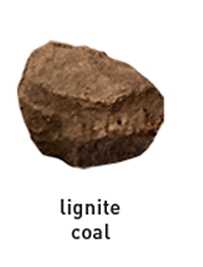
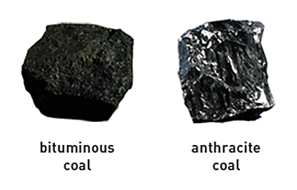
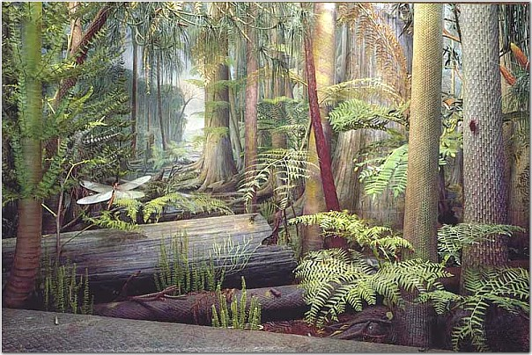From naturenorth.com

