It is 1855. You are an immigrant from Ireland who has come to live at Eckley to try and improve your life. Write a letter to the family you’ve left behind in Ireland describing your life at Eckley. Be sure to include information you learned in your lesson. You can choose to write from the point of view of a miner, his wife, or one of his children.

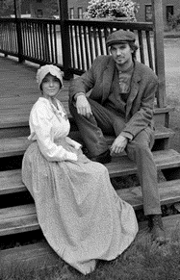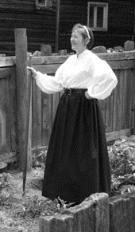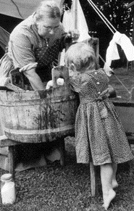

A Letter to Home

Name: ______________________________ Date: __________________

Dear __________________________________,

____________________________________________________________________________________________________________________________________________________________________________________________________________________________________________________________________________________________________________________________________________________________________________________________________________________________________________________________________________________________________________________________________________________________________________________________________________________________________________________________________________________________________________________________________________________________________________________________________________________________________________________________________________________________________________________________________________________________________________________________________________________________________________________________________________________________________________________________________________________________________________________________________________________________________________________________________________________________________________________________________________________________________________________________________________________________________________________________________________________________________________________________________________________________________________________________________________________________________________________________________________________________________________________________________________________________________________________________________________________________________________________________________________________________________________________________________________________________________________

Sincerely,